OAKLEIGH PRIMARY SCHOOL
and KINDERGARTEN

Preparing for Foundation Information Booklet

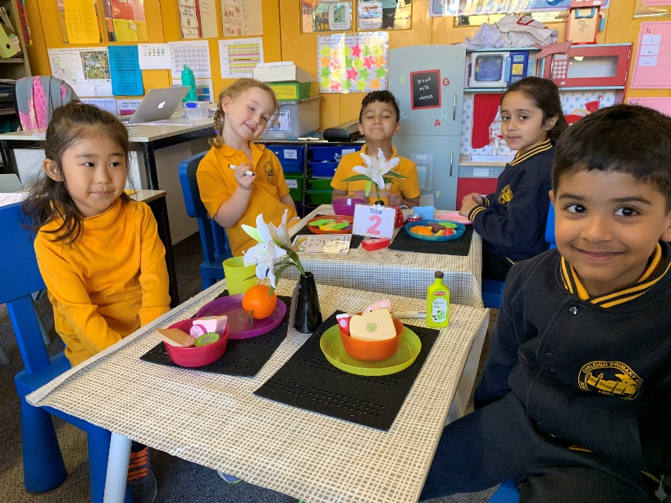

20 Warrigal Road, Oakleigh 3166
9568 0558
Website: www.oakleighps.vic.edu.au
Email: oakleigh.ps@education.vic.gov.au

Welcome to Oakleigh Primary School

On behalf of the staff, students and parents of Oakleigh Primary School and Kindergarten I welcome you and your family to our school community.
Oakleigh has a proud history as a school which values diversity and cultural difference. The many different nationalities at our school provide us with a richness derived from embracing this cross section of our community. We place a strong emphasis on the development of each individual student's learning potential through challenge, reflection, lateral thinking and optimal learning experiences. The welfare of students is a high priority as we believe students learn best when they feel safe and secure in a stimulating learning environment.
As the Principal of Oakleigh Primary School and Kindergarten I place great value in working in partnership with members of the community to provide a rich and engaging learning environment that will prepare our students to confidently embrace the wonderful opportunities our society offers them.
Starting school is a very important event in a child’s life. We work collaboratively with parents and carers to ensure that each child settles easily and happily into school life at Oakleigh Primary School.
You child’s teacher will keep you informed about how your child is settling in, and we encourage you to provide us with feedback as well. Open communication between school and home ensures that the transition to our school is as smooth as possible.
We look forward to working in partnership with you and your child at the start of their educational journey.

Michele Nolan

Principal

Introduction

The first year at school is vitally important in setting patterns and attitudes for future learning. Together we aim to develop positive attitudes which will assist your child throughout his/her school life.
At Oakleigh Primary School we put a lot of effort into ensuring transition from kindergarten to school is a successful one. We encourage your children to be independent, confident and resilient. Try not to be too anxious, as this will affect their perceptions of school. All children are individuals who learn at their own pace and they will settle in their own time.

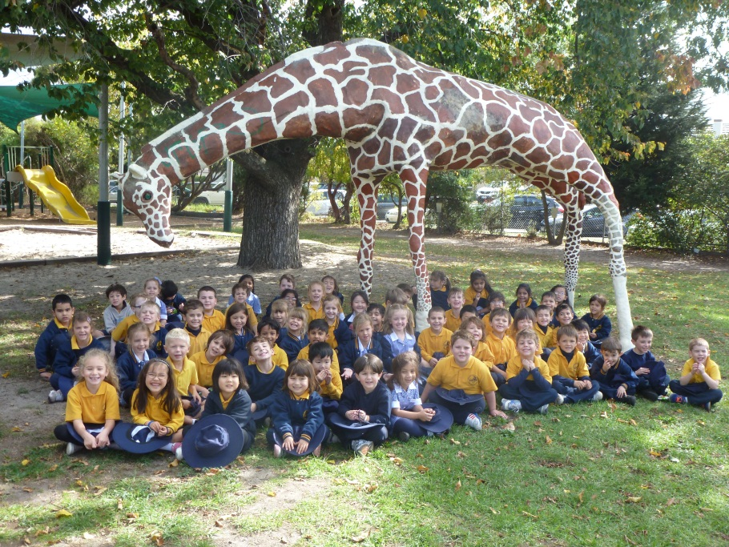

Health

If your child has an illness or condition which affects their health the class teacher should be informed. The teacher also needs to know about the effects of any treatment or medication your child is having so allowances can be made, both in and out of the classroom. The school needs to know of any diagnosed allergies or asthma that your child suffers from. Your child’s Asthma Management Plan must be sent to school as well as any action plan for Allergies.
Even though your child may want to come, school is not the place to be when your child is sick. Runny noses, temperatures, cold sores are all indicators of possible infectious conditions. As well as risking the health of others, your own child is placed at risk of further infections at a time when immunity is low. Please keep your child at home during such times.

Sleep and Diet
Starting school can be a tiring experience, even for a healthy child. If your child has a minor illness which is stopping him\her from sleeping or eating well it would be wise to have the illness treated.
It is important that your child goes to bed early, we suggest at 7.30pm, and sleeps for at least 10 hours every night. They need a healthy diet every day which should include a good breakfast – giving them the fuel to start the day.

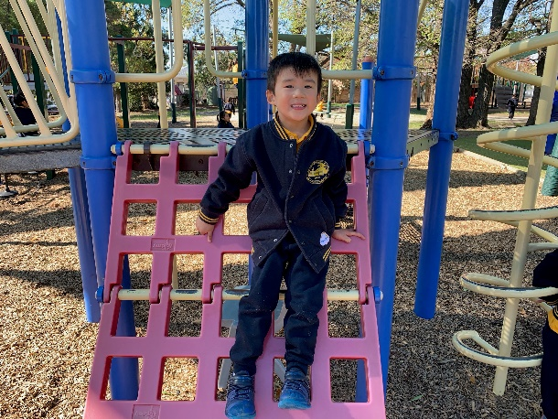
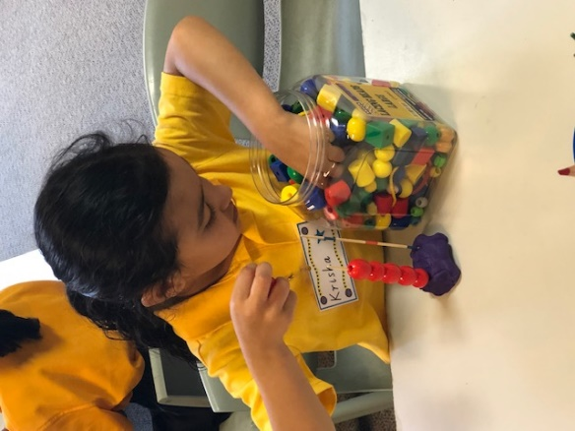

Physical Development
Skills
There are two important skills that children need at school:
- those that are necessary for looking after themselves when an adult is not able to help.
- those that enable them to join in with all learning activities at school.

These important skills include:

- Eating
At school children need to:
- feed themselves
- unwrap food packaging
- undo their lunchbox
- unscrew their drink container
- peel a piece of fruit
- get a drink from the tap
- clean up any mess left after eating including putting wrappers in the bin

- Toileting
At school children need to:
- go to the toilet by themselves
- be able to undo and do up any buttons or zips
- flush the toilet
- wash and dry their hands
- manage the taps
In the first few days of school Foundation teachers try to prevent accidents by making regular visits to the toilet.
- Dressing
Children must be able to take off and put on their windcheaters, jackets, art smocks, socks and shoes by themselves. Parents can help children to learn these skills by encouraging them to dress themselves and tie their own shoelaces. We recommend selecting shoes with velcro closings.

- Nose blowing
It is important for health and cleanliness that your child is aware when their nose needs wiping or blowing and that they are able to do this independently.
- Eye-hand coordination
This is the ability to direct the hand with the eye. It is important for many things such as writing and catching balls. You can develop these skills with activities such as using scissors, painting, drawing, colouring, water and sand play, building with blocks, throwing catching and hitting balls.
- Basic Movements
At school, children will participate in many new games and activities which include walking, running, jumping, hopping and skipping. Most children develop and refine these skills by having opportunities to play freely.

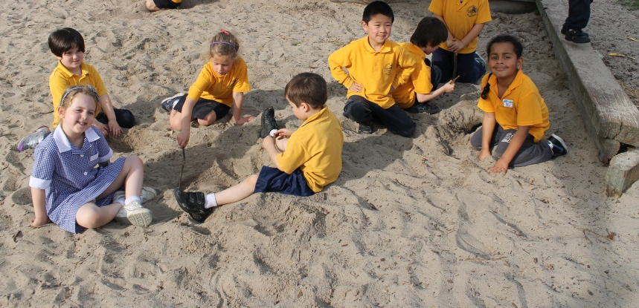
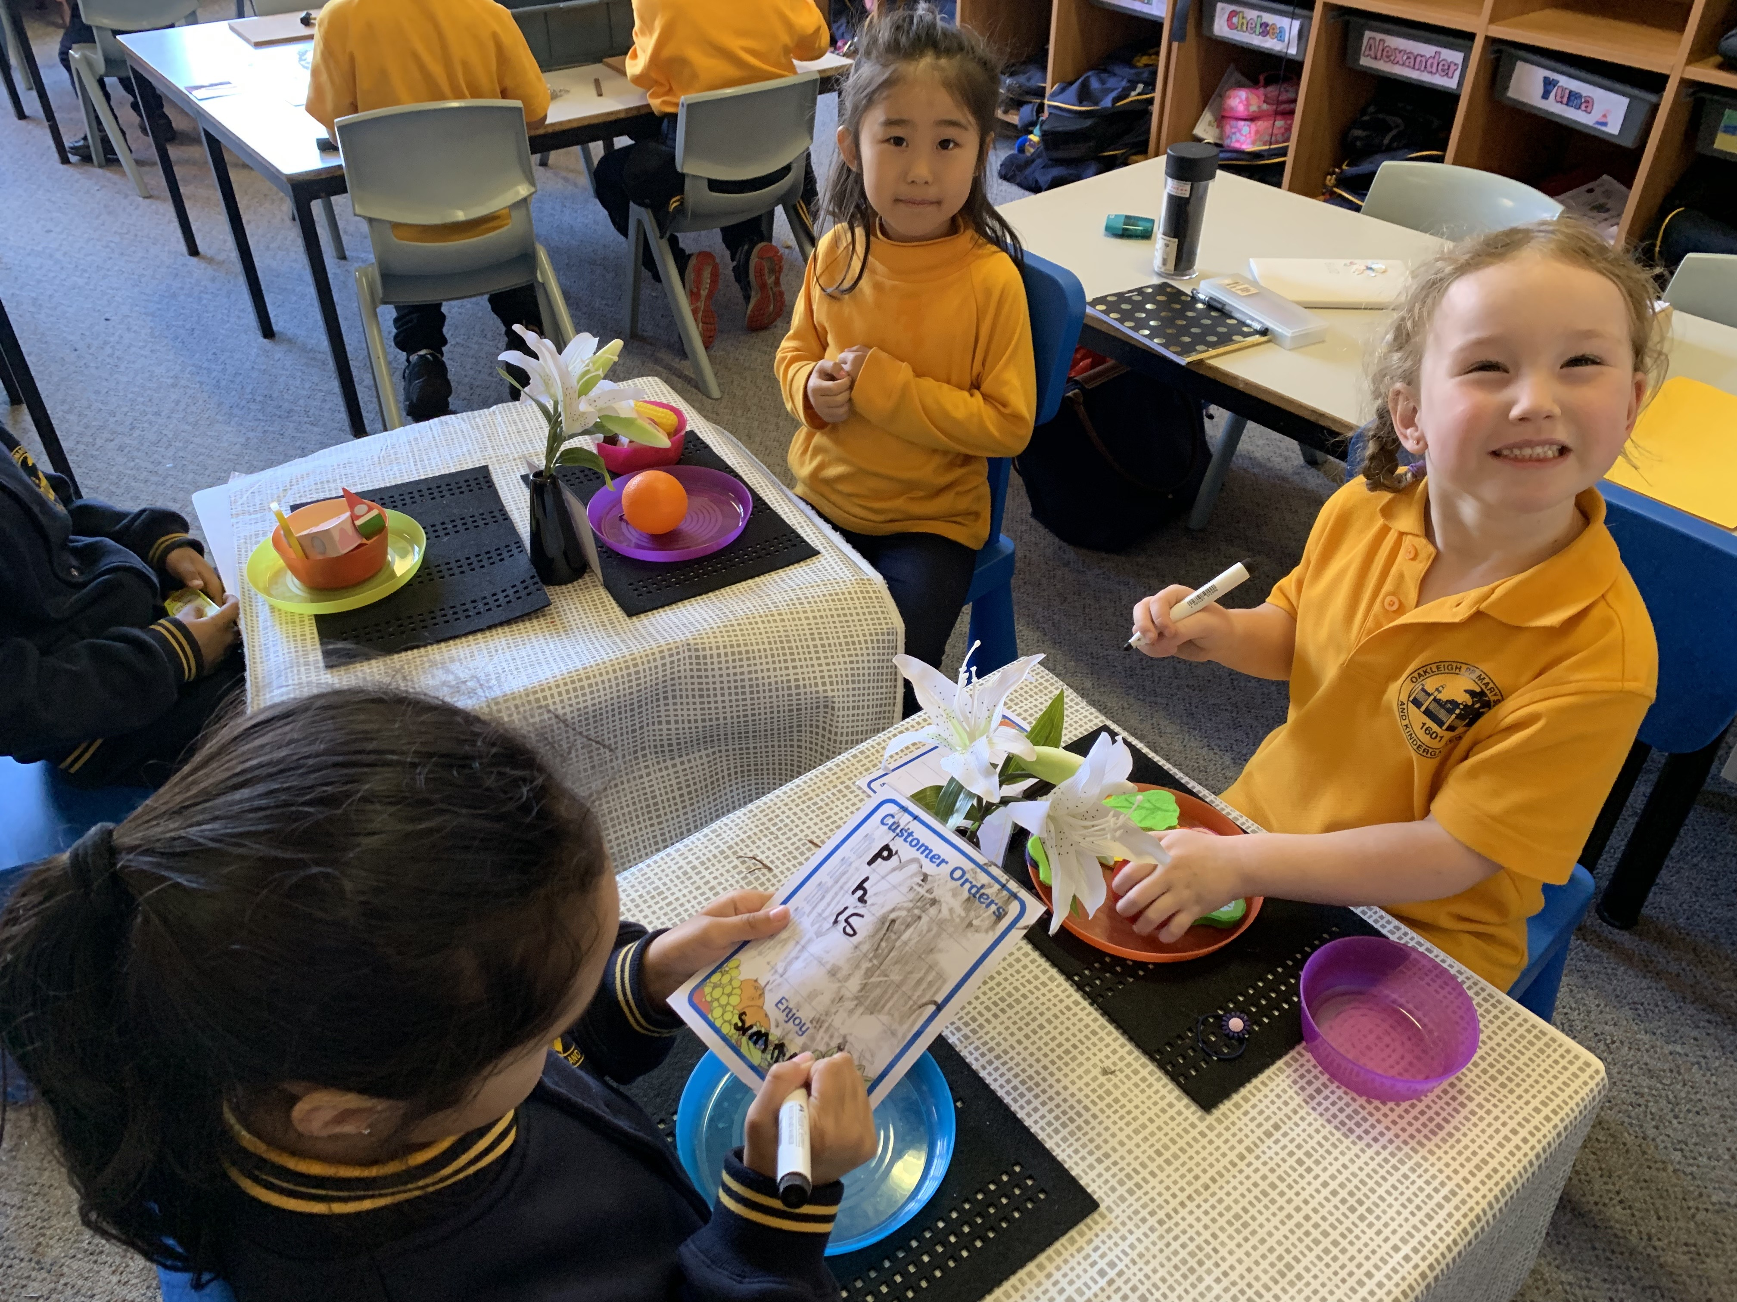
In Terms 1 and 2, our students participate in a program called PMP (Perceptual Motor Program). PMP refers to a child’s growing ability to interact with their senses and motor skills. They develop their awareness of their bodies in space and perform movement tasks, such as hitting a ball, crawling through a tube or crossing objects over their body left and right.
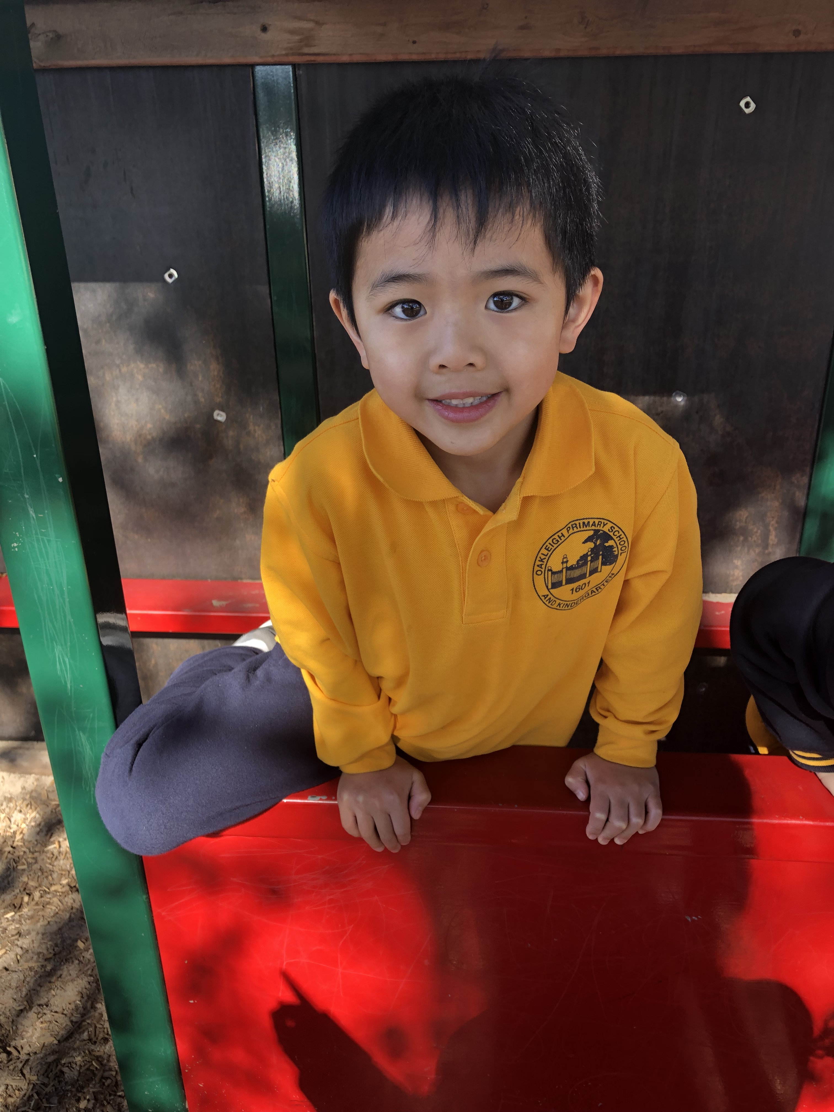
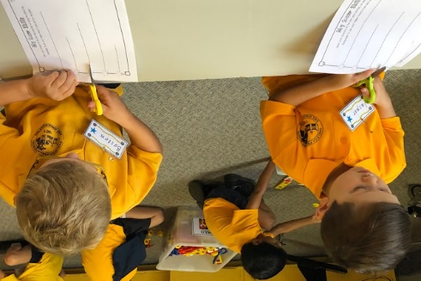

Social Development
At school children will meet and be expected to interact with many new people, both adults and children. When children have opportunities to mix with other people they learn skills to help them cope with the social aspects of school.
- Learning how to relate to adults
Children learn how to relate to adults when they:
- are minded by someone other than their parents
- play at the homes of friends
- go out with other people
- learn to ask for things in shops
- go to playgroups and kindergarten
- do not have their parents speak for them when they are asked questions.
When your child is comfortable with adults, can listen to the teacher, follow directions and make their needs known to the adults at school, learning becomes more enjoyable and successful.
- Learning how to relate to children

Children learn how to relate to other children when they have the opportunity to play together.

- Sharing, taking turns and cooperating
Children often work in groups at school and this means taking turns, sharing materials and cooperating. They also need these skills in the playground.
- children learn to share when they wait their turn or allow other children to play with their toys. They learn to cooperate when they help prepare family meals, make beds or do other simple jobs around the home.
- children feel rewarded when parents notice these things and praise them for their efforts.
- playing games with adults also teaches children how to take turns and cope when they do not win.
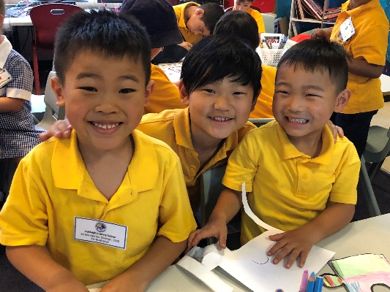
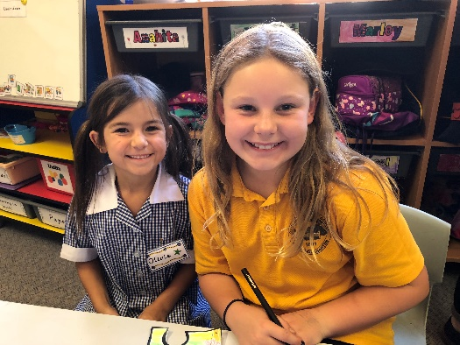

Emotional Development
- Separation
Coming to school each day is made easier if your child is able to separate happily from their parents or carers. When parents tell their child that they are going to leave but will be back, and keep their promise, the child learns to accept separation. If your child is worried about being separated from you they may not be able to concentrate and enjoy what is happening in school. It also helps if parents point out the enjoyable things their child will do at school, highlighting the positives in a cheerful and encouraging way.
Some children will find the transition to school difficult and may cry when you start to leave. Do not sneak away. Say goodbye in a calm, but firm way, letting them know that you will be back at the end of the day. Your child’s teacher knows how to deal with ‘reluctant starters’ and how to calm them once you have left by providing distractions. Most ‘upset’ children settle happily as soon as their parents have left the room.
- Self Control
At school children are expected to show some self control when playing and working with others. Often, children will lose their temper when they must wait for something or when they do not get their own way or find other children unwilling to play or work with them.
Self control is developed at home:
- when parents do not give in to temper tantrums and do not let their child always have their own way
- when the child is asked to wait while the parent finishes some activity before attending to their child
- when the parent does not give the child everything they want

- Confidence
A confident child generally sees themselves as being successful and will be better prepared to meet new challenges. Parents can build their child’s confidence by:
- praising their efforts and persistence
- praising new achievements
- encouraging the child to tackle tasks of increasing difficulty
Studies have shown that if we praise effort rather than accomplishment children learn that they can achieve anything they want with hard work. So try saying, ‘That looks wonderful, you must have worked really hard to do that’, instead of, ‘That looks wonderful. You are so clever.’ If we constantly tell them they are really clever, it has been shown that when they come to a difficult task which they find challenging they lose confidence, believing they are no longer ‘clever’.
- Responsibility
At school students will be responsible for their belongings and their work space. A sense of responsibility is developed when parents:
- encourage their child to keep their room tidy
- expect their child to put away their own toys
- encourage their child to do simple tasks around the home

- Independence

School provides a wide range of new experiences and activities for students. Those students who do not always need direction can attempt more and will probably learn more. Parents who allow their children to try things for themselves encourage growth of independence.

- Persistence
At school new tasks are based on the completion and understanding of earlier teaks. Small children often give up when a task becomes too difficult. Parents can help by assisting and encouraging them to finish a task, so that they can learn the value of persistence.

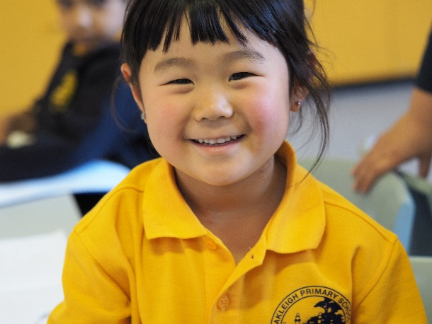
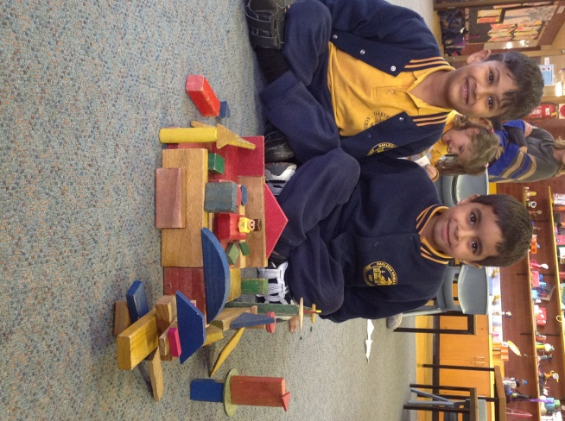
Intellectual Development
- General
Children learn by seeing, hearing, touching, tasting, smelling and doing. Children need to be given many opportunities to build, play, make, travel, observe, hear stories, complete tasks, help others, predict, experiment, listen to and play music and visit friends and families. Whenever children are active and talking about something they are doing they are learning.
Children need to be asked questions and participate in conversations with parents and other family members. While in moderation it may be beneficial for intellectual development, it is important to discourage long periods of time watching TV, playing on the ipad and using electronic or computer games.
- Clear Speech
Clear speech and vocabulary is developed over many years through role modelling, conversations and listening to others. Parents extend their child’s speech and language by talking with them and modelling good speech. Seek opportunities to learn new words through reading together, watching television programs together, family outings and conversations.

If you are worried about your child’s speech or language development you may seek advice from a speech therapist or speak to your child’s Kindergarten Teacher.

- Pre-reading Skills
Learning to read well is a complex task and usually takes years to master. Children develop a love of literature through:
- sharing books at home for enjoyment and bedtime stories
- belonging to the local Library and being able to choose their own stories
- seeing you read for enjoyment and information
To help your child prepare for reading:
- talk with your child so that they learn the meaning of words
- draw your child’s attention to signs, advertisement and writing on packets
- tell your child what is written as well as point out the differences in symbols which lead to differences in meaning, eg. men and women on toilet doors
When children are read to they learn many new things such as:
- meaning is obtained from print
- reading can be useful and enjoyable
- we read from the top of the page to the bottom, going across from left to right
  - we use pictures to add meaning to the words
- Pre-mathematics skills
Mathematics in Foundation includes:
- counting and recognising the properties of numbers eg. more than, the same as
- learning to add, subtract and group
- measuring with concrete materials and sequencing time
- recognising and creating patterns
- place and value
- recognising money
- trusting the count
Before children can work with symbols they need to understand the ideas behind them. Children who come to school understanding words such as more, less, the same as, first, last; can sort and order objects and numbers; understand time concepts eg. tomorrow, are more prepared for early mathematics.
Parents and others can help prepare children for mathematics by:
- helping the child to count a few objects eg. plates on the table
- talking to the child about time eg. when the program will finish, the days of the week, how many sleeps until your birthday and so on
- letting the child find out what they can buy with a few coins
- playing board games with dice so they learn to count on
- talking to the child as they build with blocks, eg. can you make it bigger?
- using pattern blocks or counters to make patterns, eg. red, red, blue, red, red, blue
- letting the child play with water, sand, dough etc. so that they can learn how much will fit into different sized containers
- noticing numbers/number words/patterns and shapes in our environment
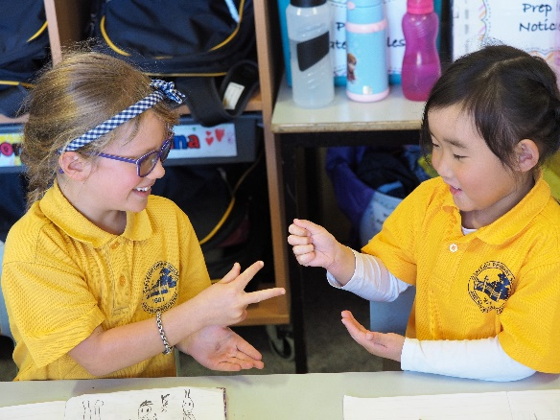
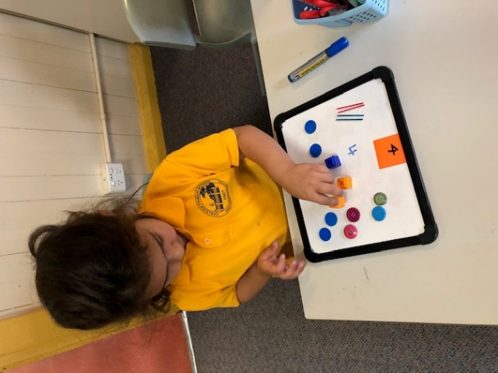

Beginning School
As the time gets close for your child to start school there are a number of things you can do the help your child settle in easily:
- walk to school with your child so that they know the way, even if you plan to drive on most days
- attend our Orientation Days so that they can become familiar with the school buildings, teachers and playgrounds
- practise with your child what they should say when they are asked their name
- write your child’s name on all their clothes and other belongings like lunchboxes and school bags. Show your child the labels so that they can recognise them when necessary.
- talk about how long the school day will be in a way that the child can understand, eg. “It is a bit longer than Kindergarten because you will have lunch and a play outside, then a story and game before I pick you up.”
- talk about the difference between ‘fruit break’, ‘playtime’ and ‘lunchtime’. Show your child what you have packed for fruit break, playtime and lunchtime and explain when they should be eaten. Make sure that your child can easily open the lunchbox and drink container.
- purchasing a school bag is recommended. It is comfortable to carry and is the correct size for all the things your child will have to carry to and from school. Attach a recognisable key tag to your child’s bag so that they can easily identify their bag.

Parent/School Relationships
You can foster a positive school community relationship by:
- using the Communication Book or speaking to your child’s teacher if you want to tell them something about your child or discuss their progress. ‘Getting To Know You Meetings’ are held early in the year, to give you a chance to talk with your child’s teacher in depth.
- helping the school community with things such as being a Classroom Helper, becoming a member of the School Council, a Class Representative
- reading the School Newsletter to keep informed about events happening at school
- looking in your child’s bag regularly for additional notices and returning them promptly when required (these will be in the Communication Book)
- attending special school events such as, The Welcome Picnic, Information Evenings, Open Nights, The Arts Festival
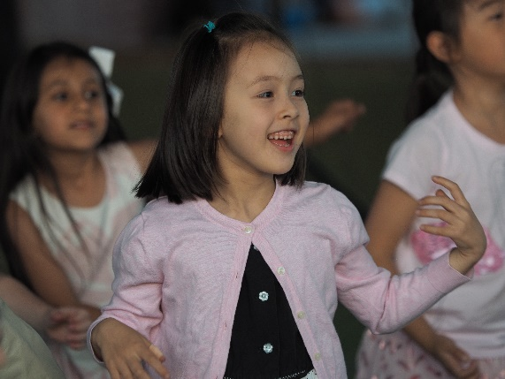

Transition – A Positive Start to School
Summary – 10 Quick Tips for a Successful Transition
- Encourage your child to ask questions about going to school.
- Help your child stay healthy – establish an early bedtime routine and eating a healthy breakfast well before school starts.
- Encourage your child to try to do things on their own, eg. dressing, washing their hands, unwrapping their food and opening their drink bottle.
- Familiarise your child with staff names.
- Show your child where the school is and talk about how you will travel to and from school.
- Arrange playtimes with other families whose children will be going to the same school as your child.
- Practise the things your child will need to do to get ready for school, eg. dressing themselves, putting things in their school bag, eating breakfast.
- Practise putting on and taking off school uniform including art smock, school shoes and windcheater.
- Arrive at school on time at 8:50am. A late arrival will cause your child anxiety. Avoid unnecessary absences. It is important that your child attends school every day.
- Be positive about starting school and enjoy your child’s excitement.

And finally,
We look forward to building productive partnerships as we grow and learn together. We are here to provide a quality Foundation education for your child. Please do not hesitate to discuss any questions or concerns you may have. We are looking forward to our association with you and your child this year in Foundation at Oakleigh Primary School.

